 | Lake Rabun  Best Practices  Boating Class | 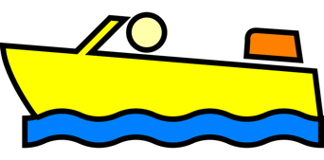

Rules of the Road

- Avoid a collision even if that means violating the other rules of the road!
- Who has the right of way?
  - Give-way vessel (must yield) - With a few exceptions below, if another vessel is in your “Danger Zone,” an arc of 112.5 degrees measured from dead ahead to just behind or aft of the starboard or right beam you must yield. If another vessel is in your Danger Zone, you are the Give-Way Vessel and must yield. The give-way vessel must take early and substantial action to keep clear of the stand-on vessel and yield. (See chart below.)
  - Stand-on vessel (maintain course and speed) - The stand-on vessel has the right-of-way and should maintain course and speed. (See chart below.)
- Drive on the starboard or right side of the lake as much as practicable.
- If operating a powered vessel, you must yield and give way to:
  - Any vessel not under command, such as an anchored or drifting vessel not underway
  - Any vessel restricted in its ability to maneuver, such as an unpowered vessel.

Tip - Boat responsibly and courteously, just as you would want your neighbor to operate his vessel.

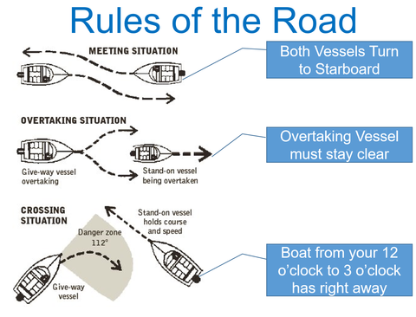

Operating Techniques
Idle Speed/ Planing Basics
- Displacement mode – The boat hull rides level in the water, similar to a displacement vessel. For Lake Rabun vessels, typically less than 5 mph. There will be little to no wake, and no bow wave.

- Plowing mode – The hull will show a distinct slant, with the bow raised. This condition reduces the vessel operator’s vision and throws a large wake. Unless specifically towing a wake surfer, avoid maintaining a speed that places a vessel in plowing mode. For Lake Rabun vessels, this is typically from 5 – 15 mph.

- Planing mode – A vessel is operating in planing mode when the hull is level to slightly raised at the bow and is moving at a sufficient speed to glide across the top of the water. Operator visibility is good as the bow drops from plowing, and wake size diminishes. For Lake Rabun vessels, this is typically above 15 mph.

Tip – Be a courteous boat operator. Avoid operating in plowing mode to reduce large wakes. If in plowing mode, either slow down to drop into displacement mode or speed up to planing mode.

Unlawful Operation per Georgia Law
- Insufficient distance from other vessels, shoreline, docks or boathouses, or persons in the water. Any motorized vessel operating above idle speed must be 100 feet from the shore, shoreline structures, moored or adrift vessels and persons in the water.

Tip – The 100-foot rule applies to the vessel OR any towed person or tube outside the wake of the tow vessel, whichever is closer to another vessel, shoreline, dock or boathouse, or person in the water. Consider that extra distance to maintain the required buffer.

- Children under the age of 13 must wear a USCG approved PFD while onboard any vessel underway.
- All persons riding on a PWC must wear a USCG approved PFD.
- All persons engaged in towed water sports must wear a USCG approved PFD.
- Operating after sunset or before sunrise (NOT “dusk” or “dawn”) without navigation and anchor (stern) lights. Note: the time of sunset and sunrise varies during the year and may be found on most weather websites.
- Operating a PWC between sunset and sunrise (NOT “dusk” or “dawn”). Note: the time of sunset and sunrise varies during the year and may be found on most weather websites.
- Unsafe or excessive speed.
- Riding on the bow or gunwales of a vessel underway. This includes riding outside the railing of a pontoon boat.
- Boating under the influence.
- Exceeding the vessel’s stated passenger capacity.
- Not having properly sized PFDs for every passenger on your vessel, as well as a throwable PFD on all vessels 16 feet in length or longer.
- Always carry a copy of your driver’s license and boat registration on board.

Who may operate a boat in Georgia?
- Persons less than 12 years of age:
  - May NOT operate any vessel 16 feet or longer.
  - May legally operate a vessel less than 16 feet in length and powered by a motor of 30 HP or less ONLY IF accompanied by a competent adult.
- Persons 12 through 15 years of age:
  - May not legally operate any vessel 16 feet in length or longer.
  - May operate a PWC or a vessel less than 16 feet in length, if:
    - The operator has passed a boating education course approved by the GA DNR, or
    - Is accompanied by a competent adult.
- Persons 16 years of age or older:
  - May operate any vessel (with proper identification on board), and
  - Any operator born on or after 1/1/1998 must have passed a boating education course approved by the GA DNR

Practical Implications of the New Wake Surfing Law

Amendments to § 52-7-3 and § 52-7-13 (see Addendum) have practical implications for Lake Rabun boaters:

- The law regulates the activities of wakeboarding and wake surfing, and not any particular type of boat.
- The law establishes an expanded 200-foot buffer while engaged in wakeboarding and wake surfing, from the shoreline and shoreline structures, and any moored vessels. Note that existing 100-foot buffer requirements for all boats remain in effect and unchanged.

Tip - The 200-foot rule applies to a tow vessel engaged in wakeboarding or wake surfing OR any wakeboarder or wake surfer if outside the wake of the tow vessel, whichever is closer to the shoreline, shoreline structure or moored vessel. Consider that extra distance to maintain the required buffer.

- The Narrows are less than 400 feet wide, so wakeboarding and wake surfing are prohibited in the Narrows.
- The law defines wake surfing to include generation of a wake that is capable of being surfed, so the 200-foot buffer applies anytime such a wake is being generated, even if there is no surfer in the water.
- The law will be enforced by the Georgia DNR, sometimes assisted by Rabun County law enforcement. The DNR will interpret the law using their best judgment for any potential violation and determine whether a warning or a citation is warranted.

Lake Rabun Best Navigational Practices

Best practices for the following areas:

- Narrows
  - Keep as far to the right or starboard as possible.
  - Stay alert for oncoming boat traffic.
  - Overtaking vessels should slow as required and wait for any passing boat traffic moving in the other direction. Be patient. It isn’t called the Narrows by accident, and we want zero accidents.
  - No wake zone above the buoys at the boat ramp and Rabun Beach.

- Big Basin/ Pigeon Mountain Run Intersection (Carter’s Point)
  - Stay wide at the point, and do not “cut the corner”.
  - Headed up the lake (towards Seed Lake) – maintain 100 (or 200) feet from starboard or right side of vessel, continue straight until vessel operator can see into the entire Big Basin. Only then begin turn to port.
  - Headed down the lake (towards Mathis Dam) – maintain a minimum 100 (or 200) feet, more is preferable, from starboard side of vessel, continue around point just until vessel operator can see down Pigeon Mountain Run. Make turn to starboard, be prepared to slow or stop for oncoming boat traffic.

- McManus Point (midway of Pigeon Mountain Run)
  - Stay wide at the point, and do not “cut the corner”.
  - Headed up the lake (towards Seed Lake) – maintain 100 (or 200) feet from starboard side of vessel, continue straight around McManus Point until vessel operator has visibility into the upper Pigeon Mountain Run (towards Big Basin). Only then begin turn to starboard, maintaining minimum 100 (or 200) feet from starboard shoreline.
  - Headed down the lake (towards Mathis Dam) – maintain 100 (or 200) feet from starboard side of vessel, continue around McManus Point just until vessel operator can see down lower end of Pigeon Mountain Run. Then begin turn to port to enter lower end of Pigeon Mountain Run.

- Entrance to Hall’s Boathouse
  - No wake zone starting at the buoys.
  - Upon entering the no wake zone, stay as far to the right or starboard as possible.
  - Exiting Hall’s and headed towards Mathis Dam, veer to starboard or right exiting Hall’s all the way across Hall’s Basin and stay to starboard or right until clear of Witham Point. Only then begin your turn to port or left. Do not remain close to the shore paralleling Witham Point, as that is too far to the left.
  - All towed sports participants should be taken on board their vessel before entering Hall’s Boathouse cove – no tow ropes, tubes or tubers in the water beyond the no wake buoys.
  - If gassing up, turn on blower and raise engine cover.

- Witham Point
  - Stay wide at the point, and do not “cut the corner”.
  - Headed up the lake (towards Seed Lake) – maintain a minimum of 100 (or 200) feet from starboard side of vessel at Witham Point, continue straight until vessel operator can see around the point into Hall’s Boathouse Basin. Then turn to starboard and continue along the shore towards Hall’s. Once fully clear of Witham Point and well into the basin, make a turn to port or left to head into lower end of Pigeon Mountain Run.
  - Headed down the lake (towards Mathis Dam) – Stay far to the right, maintain 100 (or 200) feet from shore on starboard side of vessel, remain wide of Witham Point and continue parallel to Witham Point until operator can see around the point into the Lower Basin. Then commence port turn into Lower Basin.

- Boat Church (Sunday mornings from 10:00 am – 11:00 am; Memorial Day to Labor Day)
  - No wake entering or departing the vicinity of the Boat Church basin. Boats are generally adrift and vulnerable to any wakes. No wake from Douglass home (on starboard headed towards Mathis Dam – house with four-bladed bronze prop on boathouse) until around and past Witham Point.
  - Avoid passing through the Boat Church area during Boat Church if possible. If passage cannot be avoided, no wake and no music.

- Mathis Dam
  - Stay away from the dam, particularly if engaged in towed water sports.
  - If the red lights are flashing on the top of the dam, one or more flood gates are open and represent a hazard.

Tip – Mathis Dam floodgates are approximately eight feet tall, and if open create a strong current over the top of the dam. If the red lights are flashing, stay away from the dam and outside of the caution buoys.

  - The water intake to the right of Mathis Dam supplies water through two tunnels to the Terrora Power Plant hydro facility on the other side of the mountain. There is not necessarily any indication when water releases are underway so stay well clear of the water intakes.

- Wooden Boat Parade
  - Vessels observing the parade should avoid narrow areas and blind spots and stay towards the middle of the lake from the wooden boat procession.
  - Do not engage in towed water sports around the wooden boat parade.

- Fireworks
  - Arrival into Lower Basin – no wake zone beyond Witham Point
  - Departure – no wake zone back to your boathouse, and do not pass the lead boats with flashing lights.

- High Water
  - If Lake Rabun is flooded (water level is within a foot of the top surface of most docks) observe no wake protocols to avoid property damage.
  - If in doubt regarding flood water levels, go to LakeRabun.org or to the Lake Rabun Association Facebook or Instagram pages for information about a no wake declaration.

Towed Water Sports Techniques

- General requirements
  - All persons being towed must wear a USCG approved PFD.
  - No towed water activities between sunset and sunrise (NOT “dusk” or “dawn”). The time of sunset and sunrise change during the year and may be found on most weather websites.
  - All vessels engaged in towed water activities MUST have either: i) an observer, or ii) a wide-angle mirror.
  - Under GA law, a PWC engaged in towed water activities MUST be rated for three persons and have a rear-facing observer. A wide-angle mirror may not substitute for an observer on a PWC.

Tip – If following a boat engaging in towed water sports, keep well behind the tow vessel, preferably more than 200 feet. Should a rider fall, it is your obligation to avoid a collision, and distance equals time to react. If possible, do not remain directly behind the tow vessel, and move to either side to pass.

- Tubing
  - Tubing is fun but requires common sense by the operator. In heavily trafficked areas avoid too many sharp maneuvers to reduce risk of collision and avoid throwing a tuber into the water close to other vessels.
  - It is strongly recommended that the tubing tow vessel have an observer on board so that the operator may dedicate undivided attention to navigation and pay close attention to other boats. Do not rely on a mirror when tubing.
  - Attach tube tow ropes to the rear transom ski rope mounts or to a dedicated ski rope pylon. Do not attach tube ropes to a wakeboarding tower as that makes it more likely that tubes become airborne in rough water.
  - Keep your distance from shore! Remember that the 100-foot rule applies, and that is determined by the distance from the CLOSER OF the tow vessel OR the tube and rider to the shore, shoreline structure, other vessels or persons in the water. The tow vessel operator needs to always maintain more than that distance on both sides of the vessel to provide a margin of safety.
Tip – It is highly recommended that a dedicated tow rope be used for tubing. These ropes are specially designed for that use and are usually only 50 feet long. That reduces the risk of tuber collision with other objects, and also reduces the speed of tubes in tight turns.

Tip - Do not make excessive maneuvers at the key points on Lake Rabun discussed above. These points are potential blind spots and could place a dislodged tuber in danger.

  - Tubers are at the mercy of the vessel operator, as they cannot steer the tube with any predictability.
  - Tube at a reasonable speed to avoid injury to riders. Speed should not exceed 15 mph for younger tubers, and 20 mph for teenagers.

Tip – If towing tubers at higher speeds, it is recommended that you not tube in the Narrows. There are limited sight lines and blind spots in the Narrows, and less room for maneuvering a vessel safely.

  - Keep in mind that in a tight turn the tube can travel as much as twice as fast as the tow vessel.
  - An observer be used to watch tubers, and not rely solely upon a mirror. That is particularly true If towing multiple tubers and/or multiple tubes.

Tip - It is strongly recommended that the tubing tow craft have an observer on board so that the operator may devote undivided attention to navigation and pay close attention to other boats. Do not rely on a mirror for tubing.

  - If one tuber falls, immediately turn the vessel to retrieve the fallen rider. A fallen tuber has no ski, wakeboard or wake surf board to raise for visibility, so return as quickly as possible.

- Wakeboarding
  - Heed § 52-7-13 Amendments (HB 121)
  - Start and stop a wakeboard run in open water with clear visibility. Do not start at or near one of the points described above.
  - Start at least 200 feet from the shoreline or a shoreline structure.

- Wake Surfing
  - Heed § 52-7-13 Amendments (HB 121)
  - Recommendations for responsible wake surfing.
    - Weight - Empty ballast when not pulling a surfer.

Tip – Emptying your ballast reduces wake and saves on fuel.

    - Direction - End-to-end wake surfing (i.e., wake surf from one end of the lake to the other to minimize repetitive passes)

Tip – Wake surf from one end of the lake to the other. This reduces wave action in any specific area of the lake and reduces repetitive passes.

    - Distance – Observe the 200-foot buffer but remain towards the center of the lake (i.e., exceed the 200-foot buffer when practicable)
    - Stay wide in the mentioned points and blind spots.
    - Proper Turn Around - When retrieving a fallen wake surfer, throttle back to idle or displacement mode, and turn to retrieve the rider only after the boat slows out of plowing mode.

Tip – For recommendations on Lake Rabun best practices wake surfing techniques, watch the water safety committee wake surf video at https://youtu.be/99Dbwe5F2m. For ease of use there is a QR code at the end of this section that also provides a link to the wake surfing video.

- Water Skiing
  - Start and stop a skiing run in open water with clear visibility. Do not start at or near one of the points or blind spots described above.
  - Georgia law provides an exception from the 100-foot rule allowing a skier to start and drop off at a dock or boathouse owned by the boat owner or operator.

Tip – Georgia law permits use of a wide-angle mirror so that the boat operator may serve as the observer of a water skier. It is recommended that the tow vessel have an observer on board so that the operator may devote full attention to navigation.

Other Topics

- PWC/ Jet Skis
  - Ride responsibly
  - Georgia law – PWC regulations
    - There must be a functional engine cut-off switch attached to the operator.
    - The operator and all passengers must wear a USCG approved PFD.
    - Do not operate a PWC between sunset and sunrise (NOT “dusk” or “dawn”)
    - Do not jump wakes closer than 100 feet from any vessel.
    - Stay at least 100 feet away from the shoreline, shoreline structures, or moored vessels.
    - If using a PWC for towed water sports, the PWC must be rated for the operator, the observer, and as many are being towed. There must be a dedicated observer, as a mirror is not acceptable on a PWC.
  - Georgia law – Who may operate a PWC?
    - Persons < 12 may not legally operate a PWC.
    - Persons 12-15 may legally operate a PWC only if they have:
      - Successfully completed a GaDNR boating safety class, or
      - Are accompanied by a competent adult over 18
    - Persons 16 and older may operate a PWC with proper identification (i.e., driver’s license) on board and any person born after January 1, 1998 operating a PWC must meet all requirements above, and have successfully completed a GaDNR boating safety class
  - Do not exceed the carrying capacity of the PWC.
  - If riding with a child it is recommended that the child be behind the operator to allow better visibility and control for the operator.
  - Maintain a safe speed for conditions, including other boat traffic.

Tip - Vary your PWC operating area, do not stay in one location for an extended period making “donuts” in the water. It is fun but move along.

- Electric Hydrofoils
  - An electric hydrofoil is considered a power vessel under Georgia law.
    - These vessels must be registered.
    - No one under 12 may operate an electric hydrofoil.
    - Operators must wear a USCG approved PFD.
    - While the 100 foot rule does apply, since the vessel produces no wake the 100 foot rule is not generally enforced.
  - Lack of visibility and vehicle sound is a danger.
  - Recommend a brightly colored life vest for operators to improve visibility.
  - These water vehicles should be operated within 100 feet of shore to avoid most high-speed powered boat traffic.

Tip – Operate an electric hydrofoil in coves or closer to shore and not in traffic channels to avoid more heavily trafficked areas of the lake where lack of visibility is more of a risk, particularly with younger riders.

- Music – Sound carries over the water, and everyone might not share your taste in music. If you can hear your music clearly while underway, so can everyone else on other boats, on boathouses and even at their houses. Be courteous to those enjoying the lake with you and turn the volume down.

A Closing Thought

Tip – Follow the Golden Rule of Boating, “Boat unto others as you would have others boat unto you.” Everyone has a right to enjoy our beautiful Lake Rabun, and common courtesy goes a long way.

QR Code Link
Lake Rabun best practices wake-surfing techniques

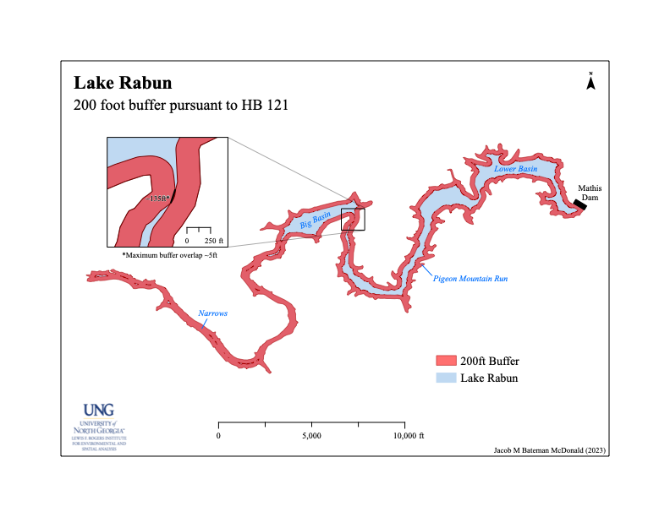
ADDENDUM

Rules of the Road – Georgia Law
Official Code of Georgia Annotated (O.C.G.A.) Title 52

§ 52-7-18. Rules of the Road for boat traffic (excerpts…)

(c) It shall be the duty of each operator to keep his vessel to the starboard or right side of the center of any channel, stream, or other narrow body of water; …

(d) Powered vessels approaching nonpowered vessels shall reduce their speed so that their wake shall not endanger the life or property of those occupying the nonpowered vessel.

(e) Whenever a vessel approaches a bend, point, or other blind area, it shall be the duty of the operator to:
1) Move as far to the right or starboard as possible,
2) Reduce speed to allow for an unexpected stop if necessary, …

(f) No person shall operate any vessel or tow a person or persons on water skis, an aquaplane, a surfboard, or any similar device on the waters of this state at a speed greater than idle speed within 100 feet of any vessel which is moored, anchored, or adrift outside normal traffic channels, or any wharf, dock, pier, piling, bridge structure or abutment, person in the water, or shoreline adjacent to a full-time or part-time residence, public park, public beach, public swimming area, marina, restaurant, or other public use area. This subsection shall not be interpreted to prohibit any person from initiating or terminating water skiing from any wharf, dock or pier owned by such person or used by such person with the permission of the owner of said wharf, dock or pier nor shall it be interpreted to prohibit the immediate return of a tow vessel to a downed water skier.

(g) No vessel shall run around or within 100 feet of another vessel at a speed greater than idle speed unless such vessel is overtaking or meeting such other vessel in compliance with the rules of the road for vessel traffic.

(h) No vessel shall be operated in such a manner as to ride or jump the wake of another vessel within 100 feet of such other vessel…

§ 52-7-3 and § 52-7-13 (Amendments regarding wake surfing and wakeboarding pursuant to HB 121)

Article 1 of Chapter 7 of Title 52 of the Official Code of Georgia Annotated, relating to registration, operation, and sale of watercraft generally, is amended by revising Code Section 52-7-3, relating to definitions, by adding two new paragraphs to read as follows:

Section 1-1. "'Wakeboarding' means the activity of: (A) Being towed on a board with or without foot bindings by a motorboat across the vessel's wake; or (B) Operating a motorboat in a manner that creates a wake while towing a person on a board with or without foot bindings. 'Wakesurfing' means the activity of: (A) Surfing a motorboat's wake, regardless of whether the person is being pulled by a tow rope attached to the motorboat that is producing the wake; or (B) Operating a motorboat in a manner that creates a wake that is capable of being surfed by another person."

Section 1-2. Said article is further amended by adding a new Code section to read as follows: "52-7-13.1. (a) Except as provided in subsection (b) of this Code section, no person shall engage in wakesurfing or wakeboarding upon waters of this state: (1) Between sunset and sunrise; (2) Within 200 feet of any moored vessel; any wharf, dock, pier, piling, or bridge structure or abutment; or any shoreline adjacent to a full-time or part-time residence, public park, public beach, public swimming area, marina, restaurant, or other public use area; or (3) When surfing a wake or being towed on a board, without wearing a personal flotation device. (b) This Code section shall not apply to: (1) A regatta, boat race, marine parade, tournament, or exhibition for which the commissioner has granted a marine event permit pursuant to Code Section 52-7-19; or (2) Intracoastal waterways, rivers, or private lakes."

